Exercise 4: Creating and Configuring a Maven Project

Creating project names Library Management
Maven dependencies
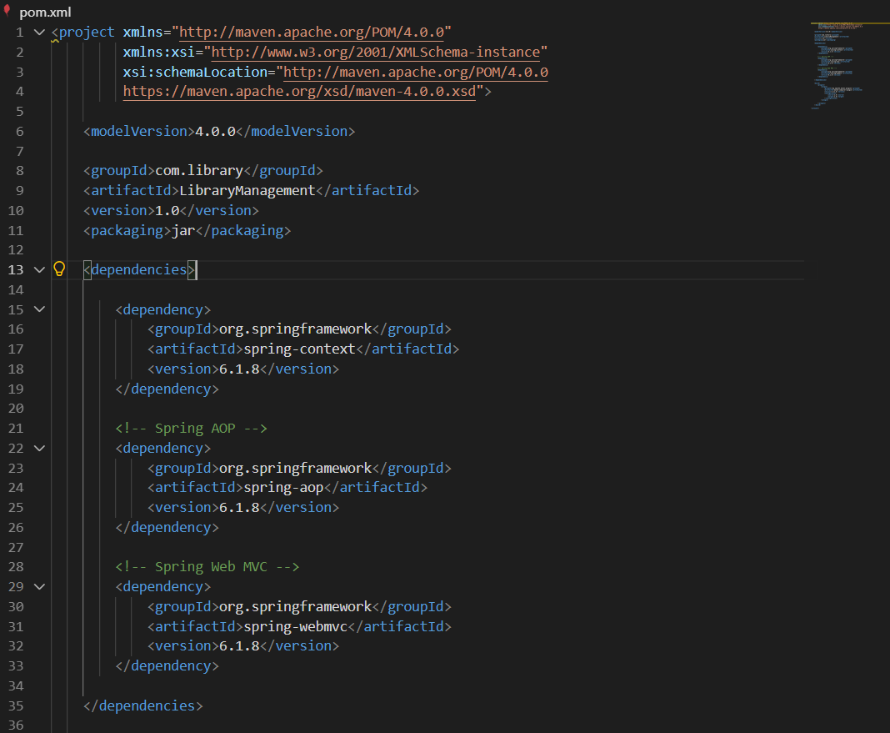

Checking Maven
